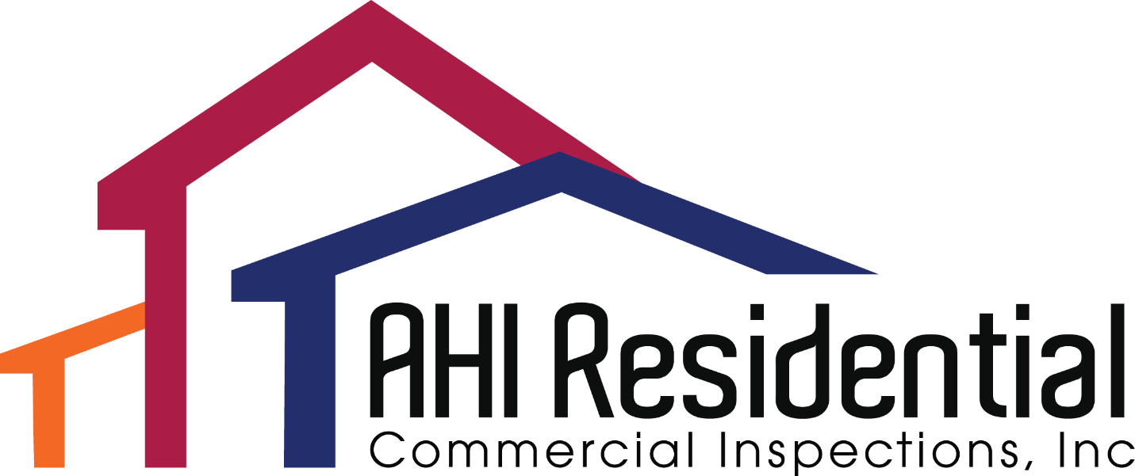

We are currently looking for new trainees wanting to enter the home inspection industry. If you are looking to join one of the most interesting and rewarding professions available, AHI Residential and Commercial Inspections just might be the place for you.

So that you understand what an incredible opportunity this is, we’re going to share with you that on average, our inspectors earn $30 an hour for the inspection.

If you want to be considered for this incredible opportunity, please complete the following questionnaire and email it to David@charlotte-inspector.com. Please note, incomplete questionnaires will not be considered.

NAME: DATE:
1. What are you doing now?

2. What are your annual earnings from your current position?

3. Why do you want to become a home inspector?

4. Where do you live?

5. Do you have an active NC state HI Inspector’s license? If not, are you working on getting one and if so when do you think you will have it?

6. Do you have a reliable truck to perform the inspections? Will it hold ladders and other tools?

7. Do you have a valid NC driver’s license?

8. How comfortable are you working with computers? Do you work daily with computers now?

9. How many words per minute do you type?

10. Crawlspace/Attic: Are you comfortable in confined spaces?

11. Are you available to work on Saturdays, at least half a day?

12. Do you have any re-occurring personal commitments, which we should know about?

13. Are you willing to invest some money in the proper inspection tools and gear?

14. Do you feel that you are capable of learning by watching videos?

15. Can you spend the necessary time reading inspection reports while you are training? We require 4-5 reports per week.

16. We perform inspections in the Charlotte Metro Area, is that a problem?

17. Do you have a “smart-phone”? If so, what kind?

18. What is your philosophy on timeliness?

19. What are your greatest strengths in dealing with people?

20. Do you have any hobbies?

21. Are you bi-lingual? If so, what languages do you speak?

22. Any physical limitations with performing roof and or crawlspace inspections?

23. How well do you handle constructive criticism?

24. Let’s talk about what motivates you. Based on your experience, tell me what you hope to get out of performing home inspections?

25. We perform a criminal and credit background check, will that be a problem?

26. Please write a paragraph on any subject you wish. The paragraph should contain at least 5 sentences.

